Gas Box
Summary
Flow Control in a Pipe Network
This application computes the back pressure in a network of pipes fed by a system of mass flow controllers (MFC). Each MFC supplies a given flow rate to one of the pipes, and can only function correctly if the back pressure remains below 760 Torr.
The Pipe Flow Module is used to compute the pressure distribution inside the network of pipes.

Results
The given design based on the input data below will meet the specifications. The back pressure is 80.23 Torr.

Input: Model Parameters
Parameters
Name | Expression | Value | Description
Lpipe | 2[m] | 2.00 m | Pipe length
dpipe | 3.5[mm] | 0.00350 m | Pipe diameter
T0 | 300[K] | 300 K | Temperature
Pout | 10[Torr] | 1.33E3 Pa | Process chamber pressure
Lspace | 0.125[m] | 0.125 m | Spacing between pipes
Nmfc | 8 | 8.00 | Number of flow controllers

Input: Mass Flow Controller Properties
Mass flow controller values
Flow rate (sccm) | Molecular weight (kg/mol) | Dynamic viscosity (Pa-s)
100 | 0.032 | 2.0E-5
200 | 0.028 | 1.78E-5
300 | 0.146 | 1.38E-5
1000 | 0.004 | 1.9E-5
250 | 0.032 | 2.0E-5
700 | 0.004 | 1.9E-5
2000 | 0.04 | 2.1E-5
600 | 0.028 | 1.78E-5

Detailed Results

Pressure
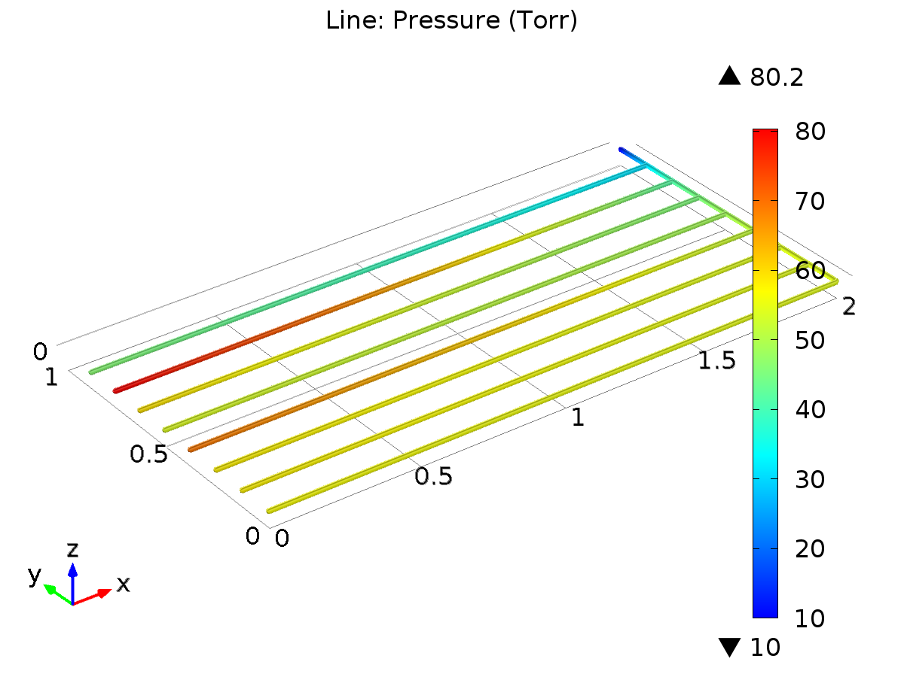
Line: Pressure (Torr)

Velocity
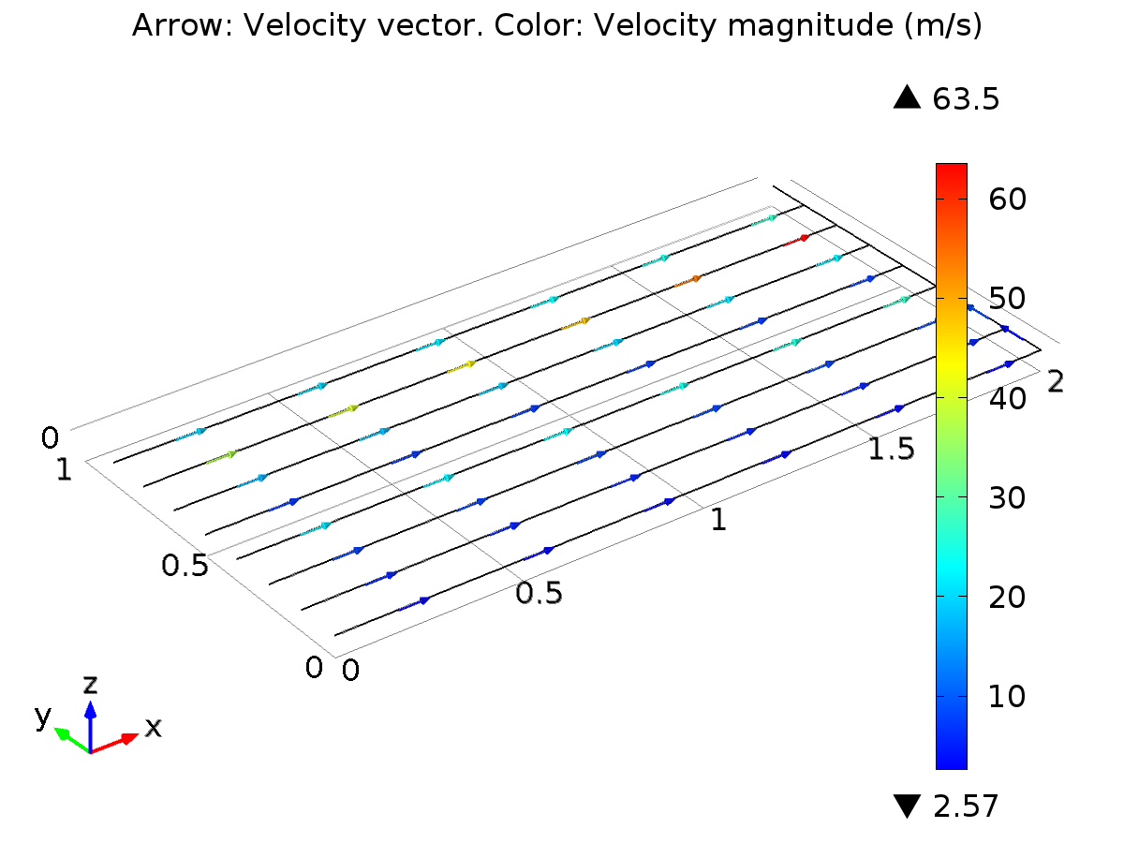
Arrow: Velocity vector. Color: Velocity magnitude (m/s)

Back Pressure
Back Pressure Value
Back Pressure Value (Torr)
80.226

