Paper Formatting & Submission Guidelines

Thank you for contributing your work to the COMSOL Conference 2018 Lausanne. Please use the following guidelines as you prepare your work for submission.

- Please use the template following this page. Your final paper should be no longer than 7 pages (there is no minimum, but please provide enough information such that the numerical modeling/multiphysics simulation work is understood).

- Please use Times New Roman font only. The size and style used throughout the template appear in Table 1 of the Appendix in the attached paper formatting guidelines.

- Save your final paper as a PDF document.
  - In Adobe Acrobat Reader, under ‘Properties’ set the ‘Default Setting’ to ‘Press Quality’.

- Submit the final PDF version of your paper online via My Conference (www.comsol.com/conference/my-conference) no later than September 28th, 2018.

For questions about paper submissions,
please contact Thierry Luthy by phone (0041 44 515 78 00) or email thierry.luthy@comsol.com).

Paper Title

J. L. Smith¹, T. M. Miller²
1. Department (if applicable), Organization, City, State (2-letter abbreviation), Country
2. Department (if applicable), Organization, City, State (2-letter abbreviation), Country

Introduction

Here, you may include some background information and describe the problem. You may want to provide an overview of the work presented in the paper. The section headings that follow are only suggestions.

Theory / Experimental Set-up

You may want to include some theory to set up the reader for your simulation work.

Governing Equations / Numerical Model / Simulation / Methods / Use of Simulation Apps

The paper should include a description of how COMSOL was used or will be used in this study (include which modules and physics interfaces were used).

The paper also should contain a mathematical description of the problem. Governing equations, initial conditions and boundary conditions may be important to include.

We encourage you to write about your use of simulation apps, if applicable.

Experimental Results / Simulation Results / Discussion

You may include color simulation images. Please export your simulation images such that the final resolution of your figures is at least 300dpi.

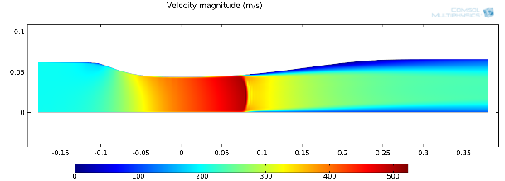
Figure 1. The caption should be centered underneath the figure and set in 9-point font.

Conclusions

You may include any implications or conclusions obtained from your work. You may include plans for future work.

References

1. Author, Article title, Journal, Volume, page numbers (year)
2. Author, Book title, page numbers. Publisher, place (year)

Acknowledgements

You may include acknowledgements here.

Appendix

You may include an appendix. If so, please insert a page break before this section.

Table 1: Font sizing used in this template

Item | Font | Size
Paper Title | Times New Roman | 16 point
Abstract & Keywords heading | Times New Roman | 10 point, bold
Author Information | Times New Roman | 11 point
Corresponding author contact | Times New Roman | 10 point
Main Headings | Times New Roman | 11 point
Subsection Headings | Times New Roman | 10 point, bold
Body Text | Times New Roman | 10 point
Figure number & Table number heading | Times New Roman | 9 point, bold
Figure caption & Table caption | Times New Roman | 9 point

