Paper Formatting & Submission Guidelines

Thank you for contributing your work to the COMSOL Conference 2024 Boston. As you prepare your paper for submission, please use the paper template (page 2) to format your paper and take note of the following information:

- Your final paper should be no longer than 7 pages.
  - There is no minimum length, but please provide enough information so that your numerical modeling or multiphysics simulation work is understood.
- Please use Times New Roman font. The sizes and styles used throughout the paper template appear in Table 1 of its appendix.
- Submit your final paper as a PDF via My Conference (comsol.com/conference/my-conference/boston).
- Papers received by the final submission deadline, August 30, are eligible for consideration for the Best Paper awards.

For questions about paper submissions, please contact Yeswanth Rao by email at Yeswanth.Rao@comsol.com.

Note: All abstracts, posters, slideshows, papers, and presentations must comply with, and are subject to, our Publication Notice Agreement (www.comsol.com/conference/publication-notice/boston).

Paper Title
J. Roe¹, J. Doe²
1. Department (if applicable), Organization, City, State (2-letter abbreviation), Country.
2. Department (if applicable), Organization, City, State (2-letter abbreviation), Country.

Abstract
Insert your abstract here.
Keywords: Add keywords here.

Introduction
Here, you may include some background information and describe the problem. You may want to provide an overview of the work presented in the paper. The section headings that follow are only suggestions.

Theory / Experimental Set Up
You may want to include some theory to set up the reader for your simulation work.

Subsection
This is a subsection with a conference paper reference. Add references to the paper via References -> Citations & Bibliography -> Manage Sources. Then select the citation from the list to add it to the paper. Here is a conference paper example reference [1].

Governing Equations / Numerical Model / Simulation / Methods / Use of Simulation Apps
The paper should include a description of how COMSOL® was used or will be used in this study (include which modules and physics interfaces were/will be used).
The paper also should contain a mathematical description of the problem. Governing equations, initial conditions, and boundary conditions may be important to include.
We encourage you to write about your use of simulation apps, if applicable.

Subsection
This is another subsection with a journal paper reference [2].

Experimental Results / Simulation Results / Discussion
You may include color simulation images. Please export your simulation images such that the final resolution of your figures is at least 300 DPI.
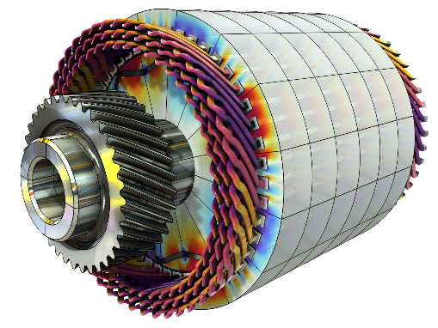
Figure 1. The caption should be centered underneath the figure and set in 9-point font.

Conclusions
You may include any implications or conclusions obtained from your work. You may include plans for future work.

References

[1] | J. Doe, "Conference Paper Title", in Conference Name, Munich, 2023.
[2] | J. Roe and J. Doe, "Journal Paper Title", Journal Name, pp. 44–45, 2023.

Acknowledgements
You may include acknowledgements here.

Appendix
You may include an appendix. If so, please insert a page break before this section.

Table 1: Font sizing used in this template
Item | Size
Paper title | 16 point
Abstract & keywords headings | 11 point
Author information | 11 point
Main section (Heading 1) | 11 point
Subsection (Heading 2) | 10 point
Body text | 10 point
Figure numbers, table numbers, and captions | 9 point, italics

